Dear amber:

Recently, I am learning how to calculate the binding free energy of receptor-ligand complex in solvated environment with MMPBSA module. And now I am repeating a example of ras-raf complex in amber tutorial. But I am confused by the result as follows due to the different versions of amber, such in tutorial the result is came from amber10,and my result is come from amber16.

I found that some parameters have changed as default values, example parameters of inp and radiopt. I have compared the result in listed:

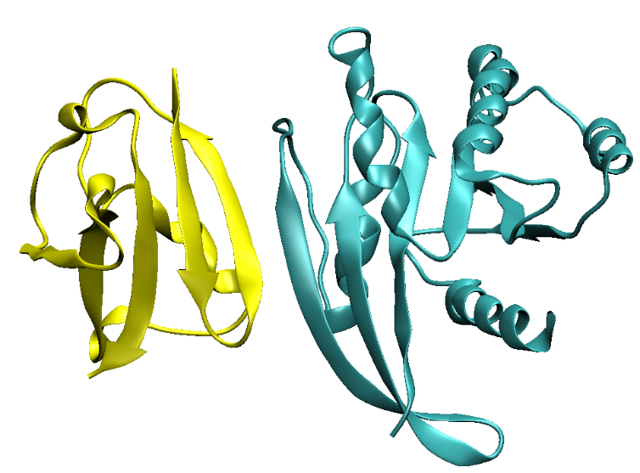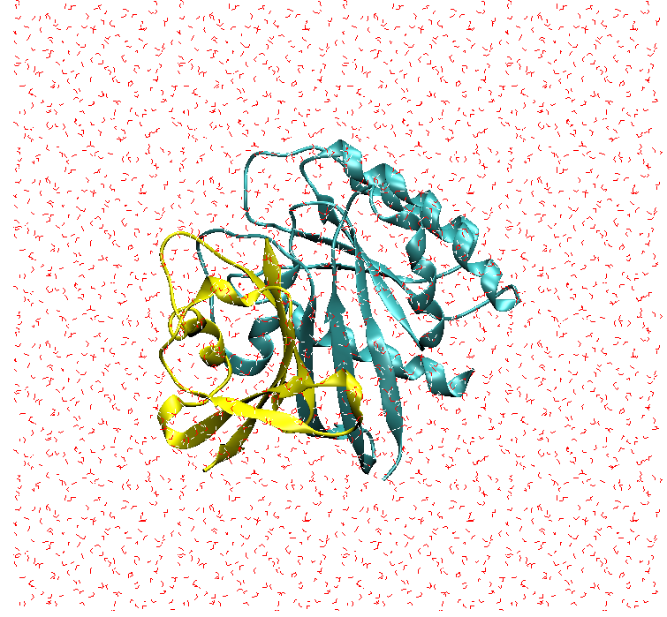

Ras – Raf Ras – Raf_solvated



Table 1：The average binding free energy without entropy effect of 50 frames from different amber versions (kcal/mol）

|  |  |  |
| --- | --- | --- |
|  | Amber10(yours) | Amber16(me) |
| Different parameter | ipb=1,  inp=1, radiopt=0 | ipb=2,  inp=2, radiopt=1 |
| ΔEmm | -1025.4769 | -1060.0425 |
| ΔEPB | 946.4251 | 978.3053 |
| ΔENpolar/Cavity | -7.3062 | -51.5872 |
| ΔEdisper | -- | 102.4891 |
| ΔGbinding (no ΔS) | -86.3579 | -30.8353 |

In your results, the binding of ras_raf complex is favored although this is not real binding free energy.

While I have done a test for choosing different parameters in amber16 with 5 frames as following:

Table 2：The average binding free energy with entropy effect of 5 frames from amber16 by choose different parameters (kcal/mol）

|  |  |  |  |  |  |
| --- | --- | --- | --- | --- | --- |
|  | Inp=0 | | Inp=1 | Inp=2 | |
|  | Radiopt=0 | Radiopt=1 | Radiopt=0 | Radiopt=0 | Radiopt=1 |
| ΔEmm | -1060.0425 | -1060.0425 | -1060.0425 | -1060.0425 | -1060.0425 |
| ΔEPB | 969.7617 | 978.3053 | 969.7617 | 969.7617 | 978.3053 |
| ΔENpolar | -- | -- | -7.5509 | -51.5872 | -51.5872 |
| ΔEdisper | -- | -- | -- | 107.2185 | 102.4891 |
| ΔSentropy | -42.0761 | -42.0761 | -42.0761 | -42.0761 | -42.0761 |
| ΔGbinding (no ΔS) | -90.2807 | -81.7371 | -97.8316 | -34.6494 | -30.8353 |
| ΔGbinding (ΔS) | -48.2047 | -39.662 | -55.7555 | 7.4267 | 11.2409 |

Actually, we can see that the binding eneries with entropy effect are differents with regulating the parameters.

The default parameter result of amber16 is 11.2409 kcal/molwith inp =2 and radiopt=1, while the binding free energy is -55.7555 kcal/mol with inp =1 and radiopt=0. Which result i can trusted and used ?

So I am evry confused of this default parameter result take depersion energy into account. And what is the favor of parameter of inp =2 comparing to inp=1.