Thanks for your kindhearted and I am very grateful for your replay .However, I have some other puzzles as following :

1.radial rdf 0.05 12 :1-229 :WAT closet density
This calculates the RDF of all atoms in residues 1 to 229 to all atoms
in all residues named WAT.

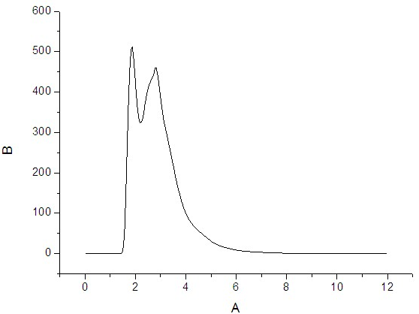
The above picture is the result that I calculate through this way .According to the things you mentioned above, can I take the meaning of this result as that a hydration layer would appear around each protein atom in a 1.8Å distance? Or any other meanings?

2. Previously , you mentioned as the following : If you are using cpptraj you can add the'center1' keyword to calculate the RDF from the center of mass ofresidues 1 to 229 to all atoms in residues named WAT, e.g.
radial 0.05 12 :1-229 :WAT center1
According to this, my input file was rewritten as:
trajin ***.mdcrd
center origin :1-229
image origin center
radial 0.05 12 :1-229 :WAT center1

the command during the calculation is：AMBERHOME/exe/cpptraj ***.prmtop rdf.in

attention BEGIN TRAJECTORY PROCESSING:
----- [last20ns.mdcrd] (1-9901, 100) -----
.... Setting up 2 actions for wat-wat.prmtop ....
...................................................
[||||||||||||||||||||||||||||||||||||||||||||||||||] Complete.

Read 100 frames and processed 100 frames.

OUTPUT:

DATASETS:
There are no data sets.
NO DATASETS WILL BE OUTPUT

I would like to know whether my input file was wrong or the command was used in an unreasonable way. I haven’t found the tools which could calculate RDF in the test of cpptraj .I want to know whether cpptraj support RDF ? I am looking for your replay.
Thank you for you help again .

